CprE 381, Computer Organization and

Assembly-Level Programming

Lab 2 Report

Student Name Will Galles

Submit a typeset pdf version of this on Canvas by the due date. Refer to the highlighted language in the lab document for the context of the following questions.

[Part 2 (a)] Draw the interface description (i.e., the “symbol” or high-level blackbox) for the MIPS register file. Which ports do you think are necessary, and how wide (in bits) do they need to be?

[Part 2 (b)] Create an N-bit register using this flip-flop as your basis.

[Part 2 (c)] Waveform.

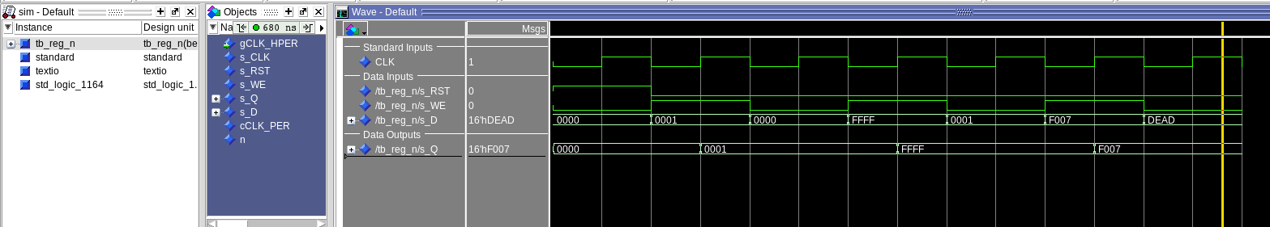

[Part 2 (d)] What type of decoder would be required by the MIPS register file and why?

We need a 5 to 32 decoder with an enable function. We need five select bits to be able to produce 32 different outputs for all of our registers. We also wan the enable functionality to be able to control later if we write to the register file at all

[Part 2 (e)] Waveform.

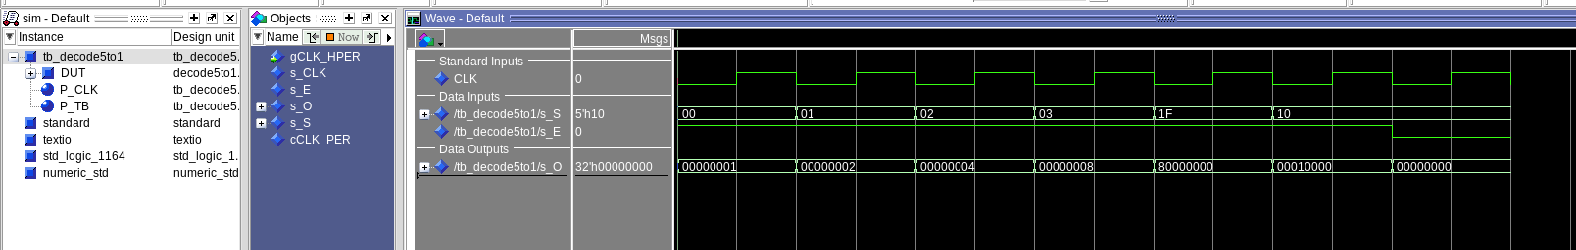

[Part 2 (f)] In your write-up, describe and defend the design you intend on implementing for the next part.

I decided to follow closer to a dataflow implementation for my 32 to 1 mux. This was because I found that it is easier to not mess up anything when you are not wiring all the internal signals between the layers of the muxes. The dataflow was also easier to read when I came back to review it at a later time.

[Part 2 (g)] Waveform.

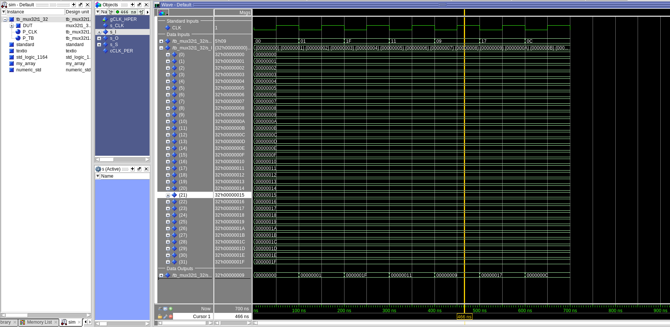

[Part 2 (h)] Draw a (simplified) schematic (i.e., components within the high-level blackbox) for the MIPS register file, using the same top-level interface ports as in your solution describe above and using only the register, decoder, and mux VHDL components you have created.

[Part 2 (i)] Waveform.

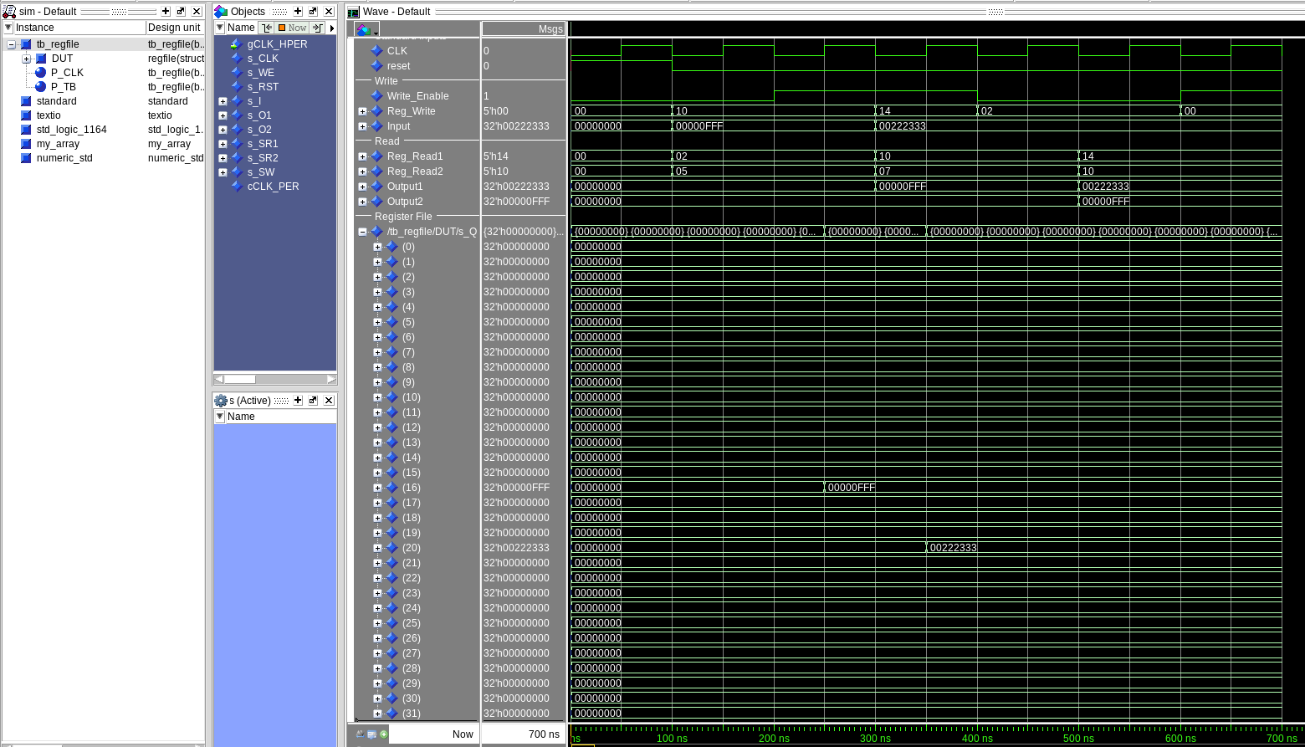

[Part 3 (b)] Draw a symbol for this MIPS-like datapath.

[Part 3 (c)] Draw a schematic of the simplified MIPS processor datapath consisting only of the component described in part (a) and the register file from problem (1).

[Part 3 (d)] Include in your report waveform screenshots that demonstrate your properly functioning design. Annotate what the final register file state should be.

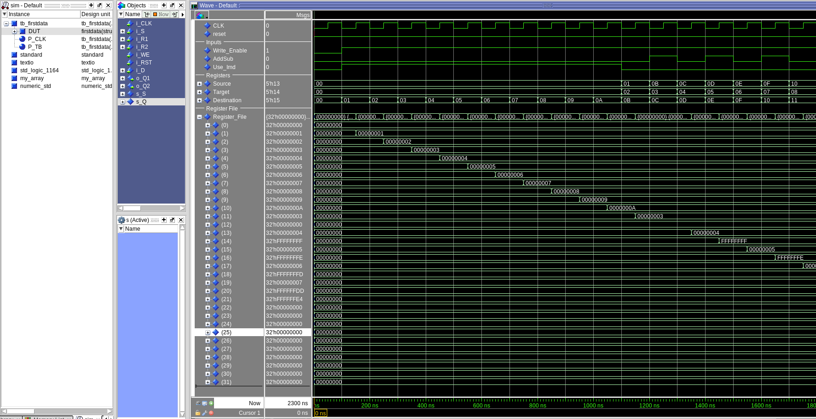

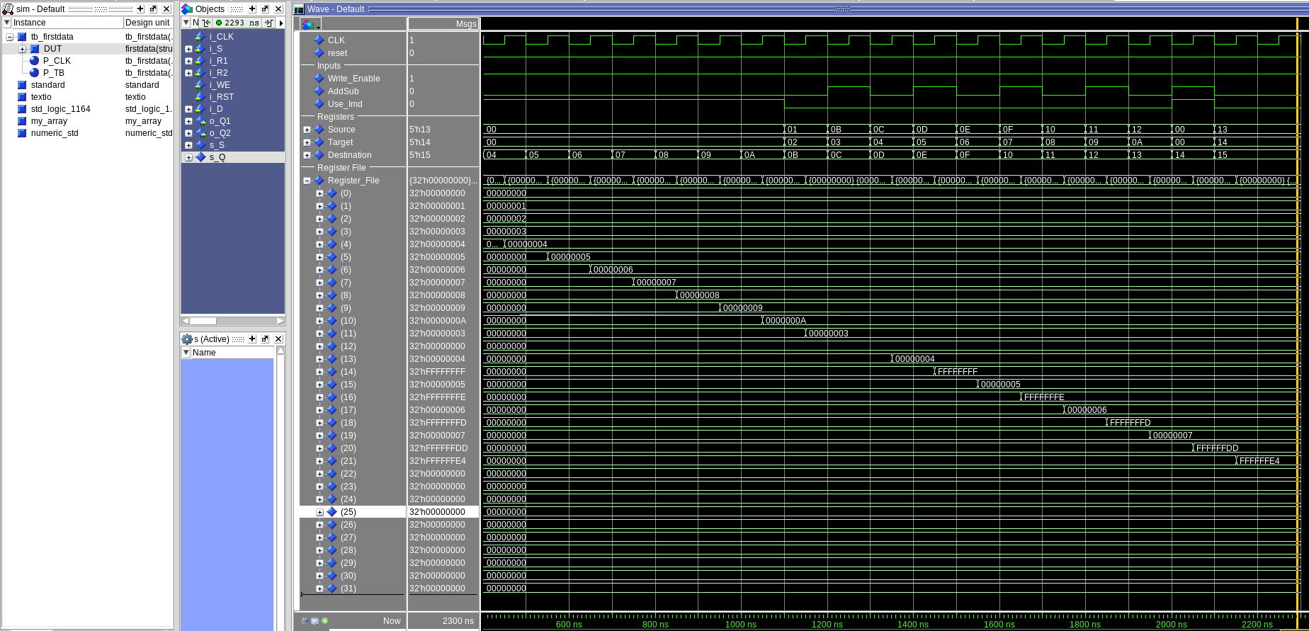

Reg | Result | Reg | Result | Reg | Result | Reg | Result

0 | 0 | 8 | 8 | 16 | -2 | 24 | 0
1 | 1 | 9 | 9 | 17 | 6 | 25 | 0
2 | 2 | 10 | 10 | 18 | -3 | 26 | 0
3 | 3 | 11 | 3 | 19 | 7 | 27 | 0
4 | 4 | 12 | 0 | 20 | -35 | 28 | 0
5 | 5 | 13 | 4 | 21 | -32 | 29 | 0
6 | 6 | 14 | -1 | 22 | 0 | 30 | 0
7 | 7 | 15 | 5 | 23 | 0 | 31 | 0
[Part 4 (a)] Read through the mem.vhd file, and based on your understanding of the VHDL implementation, provide a 2-3 sentence description of each of the individual ports (both generic and regular).

The clock port is the input for the clock that runs the internals of the memory system and provides and output and writes to itself on the positive clock edge.
The addr port is the address port of the memory module. This is used to declare where in memory you are either retrieving a value or setting a new value.
The data port is the input port to the memory module. This is where values are entered to be saved into memory based on the given address
The WE port is the write enable for the memory module. This is there so that you are able to read from the memory module without overwriting what you already have saved in it.
The Q port is the data output of the memory module. This port is responsible for displaying the value stored in the memory module at the given adderess

[Part 4 (c)] Waveforms.

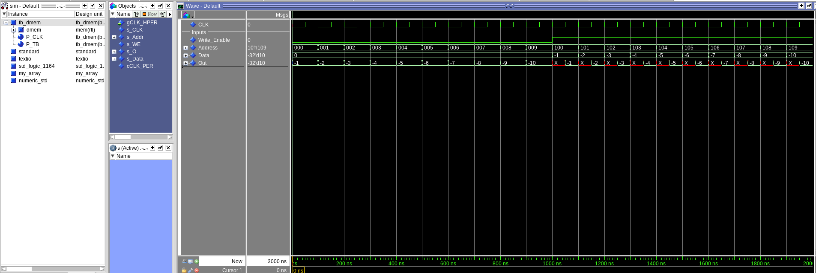

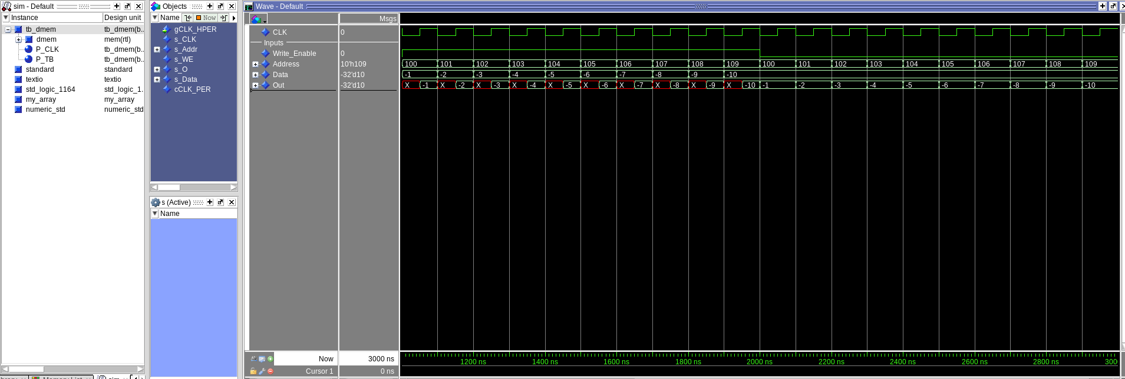

[Part 5 (a)] What are the MIPS instructions that require some value to be sign extended? What are the MIPS instructions that require some value to be zero extended?

Any MIPS function that uses the immediate in basic arithmetic operations requires it to be sign extended. Some commands that would you this would be addi and addiu along with the basic load and store commands
The MIPS commands that primarily utilize the zero extension would be the bitwise immediate operations such as andi and ori

[Part 5 (b)] what are the different 16-bit to 32-bit “extender” components that would be required by a MIPS processor implementation?

We would need one of these extenders in place to take our 16 bit immediates and translate the into 32 bits to be used in the ALU. We would also need one of these when we are using offsets when accessing memory to take our 16 bit immediate offset and change it to 32 bits for the addressing.

[Part 5 (d)] Waveform.

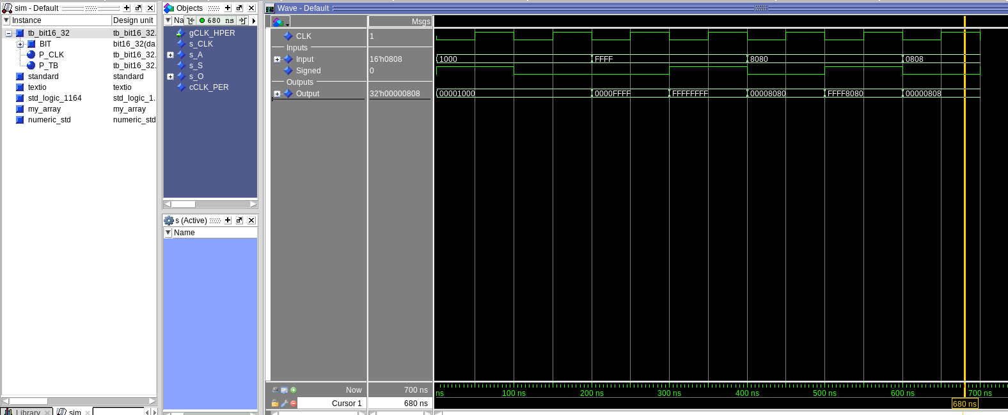

[Part 6 (a)] what control signals will need to be added to the simple processor from part 2? How do these control signals correspond to the ports on the mem.vhd component analyzed in part 3?

There are a couple of extra control signals that we need to add to this second data path. We need to add a write enable for the memory along with a select line to choose whether we are writing the output of the ALU or the output of the memory module back to the register file.

[Part 6 (b)] Draw a schematic of a simplified MIPS processor consisting only of the base components used in part 2, the extender component described in part 4, and the data memory from part 3.

[Part 6 (c)] Waveform.

